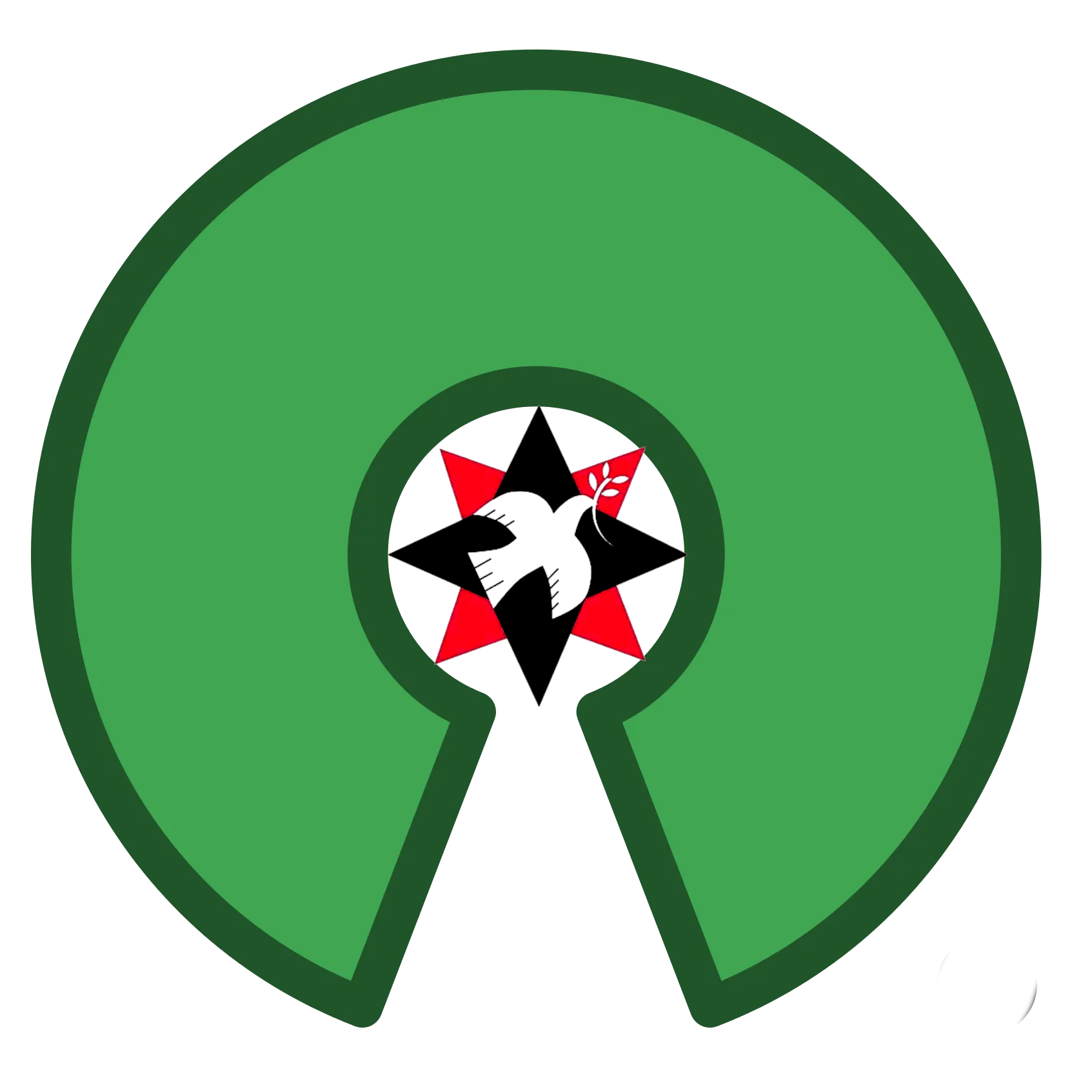

Open Source Quaker Meeting (OSQM)
by
Felipe Ribeiro
Ambassador of Peace (Amb.P.)
operarioribeiro.gitbook.io
operarioribeiro@proton.me

"That of God in everyone requires also a testimony of community."

Open Project:
Open Source Quaker Meeting (OSQM) is a collaborative open governance methodology for Religious Society of Friends meetings.

Open Program:

To Safeguard the Quaker United Nations Office (QUNO), the American Friends Service Association (AFSC) Nobel Prize, and the whole Quaker institutions ecosystem best practices and historical heritage this open source project shares Quaker Business Method procedures to remix the London Friends House open space technologies in a seven days weekly Indico public schedule:

1. Open Justice:
- Peace and disarmament programme meetings.
- Ethical Source licenses Contributor Covenant code of conduct.
- Conscientious objector civil military relations (CMR) chaplaincy.
- Rule of law regulatory compliance transparent external audit procurement.
- Public international law (PIL) legal public education.
- Constitution, statute, and bylaw open laws open access publication.
- Digital direct democracy decision making with tools like Consul Democracy and Pol.is.
- Open United Nations participation education.
- Diplomatic briefs open policymaking.
- United Nations Geneva Office (UNGO) monitoring and evaluation (M&E) weblog and reports for the Friends World Committee for Consultation (FWCC) World Plenary.

2. Open Finances:
- Sustainable Just Economic Systems Programme meetings.
- Nonprofit organization Global Standards for Civil Organizations open standardization.
- Open accountancy using tools like Open Collective.
- Ethical banking transition and sustainable disinvestment in compliance with the United Nations Credit Federal Union (UNCFU) and Global Alliance for Banking on Values (GABV).
- Endownment funds creation with the help of Intentional Endowments Network (IEN).
- Grantmaking with the help of Worldwide Initiatives for Grantmaker Support (WINGS).
- Crowdfunding fundraising with platforms like Donor Box, Chariti, Charities Aid Foundation (CAF) App, Charity Excellence, CharityStack, and CyberPeace Institute Tools.

3. Open Theology:
- Senior Staff Elders and Pastoral Support Programme secure operations development (DevSecOps) and meetings.
- Quaker chaplaincy and pastoral care formation in compliance with 'Swiss Chaplaincy Law', especially for the United Nations Geneva Office (UNGO) staff.
- Quaker universal priesthood and universal salvation, as in George Fox's "That of God in everyone.", study groups with the assistance of the Quaker Universalist Fellowship (QUF) and the Quaker Universalist Group (QUG).
- Friends United Nations Studies Society (FUNSS) creation with the help of the Quaker Studies Research Association (QSRA).
- Yearly meetings Books of Disciplines (BOD) comparative studies based on the 'Faith and Practice'.
- Secular state interfaith pluralist Quaker religious education in compliance with the Quaker Religious Education Collaborative (QREC) and the Arigatou International 'Ethics Education for Children'.
- Comparative theology studies with the Unitarian Universalist Society of Geneva (UUSG) that meets in the Geneva Quaker House.
- World Council of Churches (WCC) Geneva Office close cooperation, especially with its Historic Peace Churches Workgroup.
- 24/7 prayer room creation in town.
4. Open Education:
- Open Pedagogy Peace Education Programme secure operations development (DevSecOps) and meetings.
- Alternatives to Violence Programme (AVP), Nonviolence International Tactics, Rotary International Economics and Peace (IEP), compassionate listening humanistic reverence language nonviolent communication, modest fashion plain clothing, and teetotal temperant abstinence regular courses.
- Free libre open source software (FLOSS) transition to open science.
- Open science scientific communication congresses with the European Organization for Nuclear Research (CERN) and universities.
- Quakers in science and science religion relations congresses.
- Open educational resources (OER) of as much programs resources as possible.
- Academic open journal open access publishing with the help of the Quaker Journal and the Journal of the United Nations.
- Quaker Wikipedia articles editathons, especially with Friends schools, along the Wikimedia Movement Switzerland.
- Inclusion of Friends Universities in the UNESCO University Twinning and Networking Programme (UNITWIN) and United Nations Open Education (UNOE) for their creation of Chair Programme.

5. Open Heritage:
- Children and Youth Inclusion Programme secure operations development (DevSecOps) and meetings.
- Geneva Quaker religious heritage interfaith tours.
- Quaker heritage of antislavery, feminist, antiracist, LGBT+, welfare state, non-governmental organizations (NGOs), indigenous defense, national parks, civil movements, ecology, and informatics role on the United Nations safeguard as UNESCO Common Heritage of Humanity, in compliance with the Open Heritage Platform and Future for Religious Heritage (FRH), with the help of the Quaker History Association (QHA) and the Quaker Heritage Center.
- Quaker United Nations Office (QUNO) Heritage ecomuseum building.
- Model United Nations (MUN) and Model UNESCO with the help of World Federation of United Nations Associations (WFUNA).
- Quaker aesthetics, including Hicksite art and Shaker design, music, and dance, exhibitions and conferences about the United Nations (UN) with the help of the Pendle Hill Arts Center, Quaker Art Network (QAN), Fellowship of Quakers in Art
- Quaker poetry about the United Nations (UN) forums with the participation of the Quaker Bookshop.
- Teetotal drugs-free celebration parties with colaborative cleaning and catering and silent moments.

6. Open Diplomacy:
- Human Rights and Refugees Programme meetings.
- International Geneva literacy.
- Create an United Nations Geneva Office (UNGO) interfaith diplomacy organ with a multifaith space with the Geneva Interreligious Platform (PFIR), Creedence Informations Intercantonal Center (CIC), UNEP Faith for Earth, UNEP Inter-Agency Task Force on Engaging Faith-Based Actors for Sustainable Development, Officer of the High Commissioner on Human Rights (OHCHR) Special Rapporteur on Freedom of Religion or Belief (FoRB), and Committee of Religious NGOs at the UN (CRNGO) in compliancy with the United Nations (UN) 'High-Level Peacebuilding Interreligious Intercultural Guidelines'.
- United Nations Geneva Office (UNGO) justice equity diversity inclusion (JEDI) promotion with the Quaker Rainbow and Black Quakers Project in compliance with the Arigatou International 'Children Participation' methodology.
- Unitarian Universalist Office at the United Nations (UU@UN) direct dialogues for the participation of the Unitarian Universalist Society of Geneva (UUSG) that meets in the Geneva Quaker House in it.
- Cultural diplomacy literacy forums and all friends participation in all possible local events everyday in compliance with the International Geneva Calendar.
- Quiet diplomacy dinners with live streaming transmission and reports for partners, starting with the United Kingdom ambassador in Switzerland and the Swiss ambassador in United Kingdom.

7. Open Development:
- Human Impacts of Climate Change Programme meetings.
- Sustainable Development Goals (SDGs) green logistics.
- Coordinating Committee of International Staff Unions and Associations (CCISUA) and United Nations Volunteers (UNV) labor rights advocacy.
- Testimony of peace animal-rights defending vegetarian catering.
- Leveller peer to peer (P2P) roadside abandoned commons planting.
- Quaker institutions literacy with the assistance of the Friends World Committee for Consultation (FWCC).
- Quaker Businesses, Organizations, and Charities compliance with and inclusion in the United Nations Office for Sustainable Development (UNOSD) Global Business Compact and United Nations Industrial Development Organization (UNIDO) Global Eco-Industrial Parks Programme (GEIPP).
- Switzerland Yearly Meeting (SYM) and world monthly meetings active calling survey and consultancies.
- Local endagered communities relief in compliance with the Quaker Social Action (QSA) along the Geneva Food Pantry.
- Geneva Quaker House community orchard agroforest garden in compliance with the Regenerative Agroforestry Impact Network (RAIN).
- Oxfam International thrift store development.
- American Friends Service Committee (AFSC) Action Hour participation.
- Volunteer programme invitation to tender in platforms suchs as Idealist and Democracy Lab.
- Geneva Quaker House cowork and startups incubation grantmaking.

"Since the founding of the United Nations in 1945, Quakers have shared that organization's aims and supported its efforts to abolish war and promote human rights, economic justice, and good governance around the world. Friends' work at the United Nations emphasizes a patient, consensual step-by-step process in moving toward peace and justice."
American Friends Service Committee (AFSC)

𝑓 ℞

Licensed under Creative Commons Attributive Non-Commercial Share-Alike (CC BY-NC-SA) 4.0 along Ethical Source Do No Harm Hippocratic License 3.0 and Contributor Covenant through the European Union Public License (EUPL) Interoperability Downstream Compatibility as an United Nations Education Science Culture Organization (UNESCO) 2019 Recommendation compliant Open Educational Resources (OER) for Nonviolent Nonprofit Open Science Fair Use.
